**3RD ANNUAL COMEDY FOR THE COMMUNITY**

*Premier Sponsor*



**SPONSORSHIP OPPORUNITIES**

**Full House Sponsor: $1,000** ~ 4 admission tickets, ½-page advertisement in event program, sponsorship recognition in radio advertisements, social media recognition, company logo placed on event flyer, Partners4cd.com, and e-mail blasts, company logo placement at event

**Add a gift certificate:** In addition to your sponsorship, donate a gift card/certificate to our charity pull!

**Front of the House Sponsor: $500** ~ 2 admission tickets, ¼-page advertisement in event program, social media recognition, company logo placed on event flyer, Partners4cd.com, and e-mail blasts, company logo placement at event

**Add a gift certificate:** In addition to your sponsorship, donate a gift card/certificate to our charity pull!

**Back of the House Sponsor: $250** ~ Company logo placement in event program, social media recognition, company logo placed on event flyer, Partners4cd.com, and e-mail blasts, company logo placement at event

**Add a gift certificate:** In addition to your sponsorship, donate a gift card/certificate to our charity pull!

**Supporting Sponsor: $100** ~ Name or company listed in event program, social media recognition, name or company listed on event flyer, Partners4cd.com, and e-mail blasts

**Add a gift certificate:** In addition to your sponsorship, donate a gift card/certificate to our charity pull!

**PAYMENT OPTIONS:**

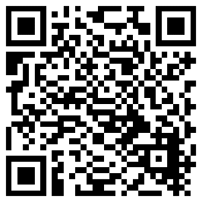

**Donate online with credit card** - To donate online, please visit [www.partners4cd.com/#partner](http://www.partners4cd.com/#partners) or scan the QR code, listing your sponsorship

level in the “Note” section.

**Check** – Please mail check with total amount along with this form to:

Partners for Community Development, Inc.

Attn: Debra Wigand

1407 S 13th Street

Sheboygan, WI 53081

**Please send me an invoice.**

**We thank you for your support of Partners for Community Development, Inc. as we provide needed services at the lowest cost to the community with the greatest impact!**